Project Planning Phase
Project Planning Template (Product Backlog, Sprint Planning, Stories, Story Points)

Date: 30 September 2026
Team ID: SWTID-2026-7613
Maximum Marks: 5 Marks

Project Name: Auto Ticket Classification using Flow Designer Team Size: 5 Team Leader: Surjith V

Product Backlog, Sprint Schedule, and Estimation (4 Marks)
Use the below template to create product backlog and sprint schedule.

Sprint | Functional Requirement (Epic) | User Story Number | User Story / Task | Story Points | Priority | Team Members
Sprint-1 | Requirement Analysis & Planning | USN-1 | As a project team, we can document the business use case and requirements for auto ticket classification. | 2 | High | Kirubakaran S
Sprint-1 | Update Set Creation | USN-2 | As a developer, I can create the Project Update Set and make it current. | 1 | High | Dinesh B
Sprint-1 | Custom Table Creation | USN-3 | As a developer, I can create the Incident WorkFlow table with Auto Number. | 2 | High | Sadasivakrishnan R S
Sprint-1 | Field Creation and Data Type Configuration | USN-4 | As a developer, I can create the ticket fields and choice lists with correct data types. | 2 | High | Sadasivakrishnan R S
Sprint-2 | Category and Subcategory Dependency | USN-5 | As a user, I can see Subcategory options based on the selected Category. | 2 | High | Vijay Ragavan S
Sprint-2 | Flow Designer Auto Classification | USN-6 | As an IT agent, I get tickets classified automatically by a flow triggered when a ticket is created. | 3 | High | Dinesh B
Sprint-2 | Wi-Fi Issue Classification | USN-7 | As a student, my Wi-Fi/Network ticket is set to Network > Wi-Fi. | 2 | High | Kirubakaran S
Sprint-2 | Projector Issue Classification | USN-8 | As a teacher, my Projector ticket is set to Hardware > Projector. | 2 | High | Dinesh B
Sprint-3 | Password Issue Classification | USN-9 | As a user, my Forgot Password ticket is set to Access > Forgot Password. | 2 | Medium | Sadasivakrishnan R S
Sprint-3 | Slow Computer Classification | USN-10 | As a user, my Slow Computer ticket is set to Performance > Slow Computer. | 2 | Medium | Vijay Ragavan S
Sprint-3 | Email Notification | USN-11 | As a caller, I will receive a confirmation email once my ticket is created. | 2 | High | Kirubakaran S
Sprint-4 | Testing and Validation | USN-12 | As a tester, I can validate the data and run the Wi-Fi and Projector test scenarios. | 2 | High | Ragulraj H
Sprint-4 | Deployment and Final Documentation | USN-13 | As a developer, I can complete and export the update set and finalize the documentation. | 2 | High | Kirubakaran S

Source: Original uploaded Project Planning Template.

Project Tracker, Velocity & Burndown Chart: (4 Marks)

Sprint | Total Story Points | Duration | Sprint Start Date | Sprint End Date (Planned) | Story Points Completed (as on Planned End Date) | Sprint Release Date (Actual)
Sprint-1 | 20 | 6 Days | 02 Feb 2026 | 07 Feb 2026 | 20 | 07 Feb 2026
Sprint-2 | 20 | 6 Days | 09 Feb 2026 | 14 Feb 2026 | 20 | 14 Feb 2026
Sprint-3 | 20 | 6 Days | 16 Feb 2026 | 21 Feb 2026 | 20 | 21 Feb 2026
Sprint-4 | 20 | 6 Days | 23 Feb 2026 | 28 Feb 2026 | 20 | 28 Feb 2026

Velocity:
Imagine we have a 10-day sprint duration, and the velocity of the team is 20 (points per sprint). Let’s calculate the team’s average velocity (AV) per iteration unit (story points per day)
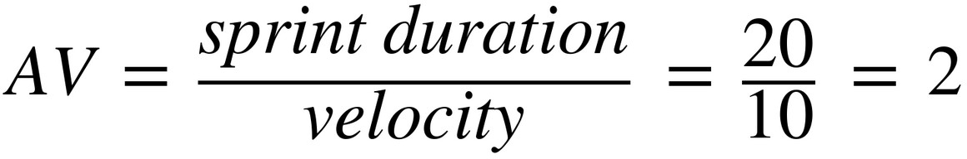

Burndown Chart:

A burndown chart is a graphical representation of the work remaining versus time. It is used to track the progress of the Auto Ticket Classification using Flow Designer project across different sprints.

For this project, the burndown chart represents the completion of tasks related to:
- Requirement Analysis and Planning
- ServiceNow Backend Configuration
- Category and Subcategory Dependency
- Flow Designer Automation
- Email Notification
- Testing and Validation
- Deployment and Documentation

The chart shows how the remaining Story Points decrease as the team completes the planned tasks during each sprint.

References:

https://www.atlassian.com/agile/project-management

https://www.atlassian.com/agile/tutorials/sprints

https://www.atlassian.com/agile/tutorials/epics

https://www.atlassian.com/agile/tutorials/burndown-charts

https://www.atlassian.com/agile/project-management/estimation

